Created Service Key Vault and Secrets

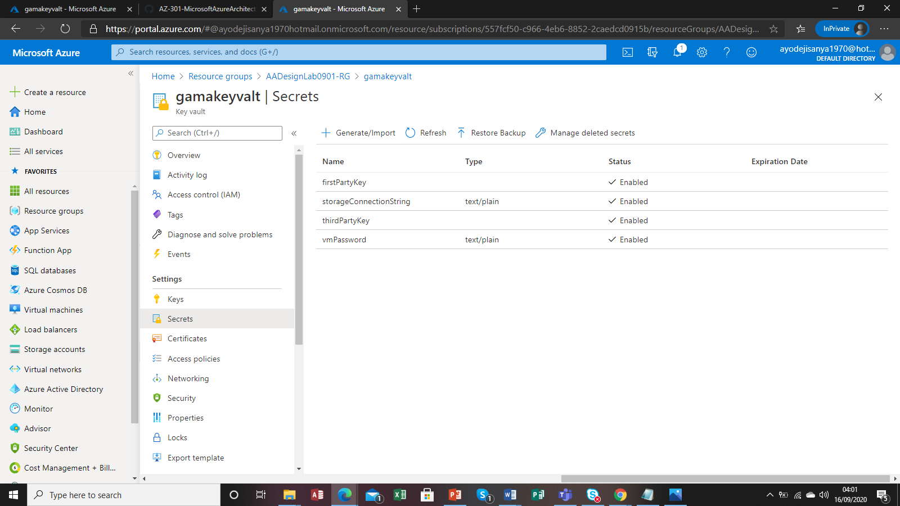

Error

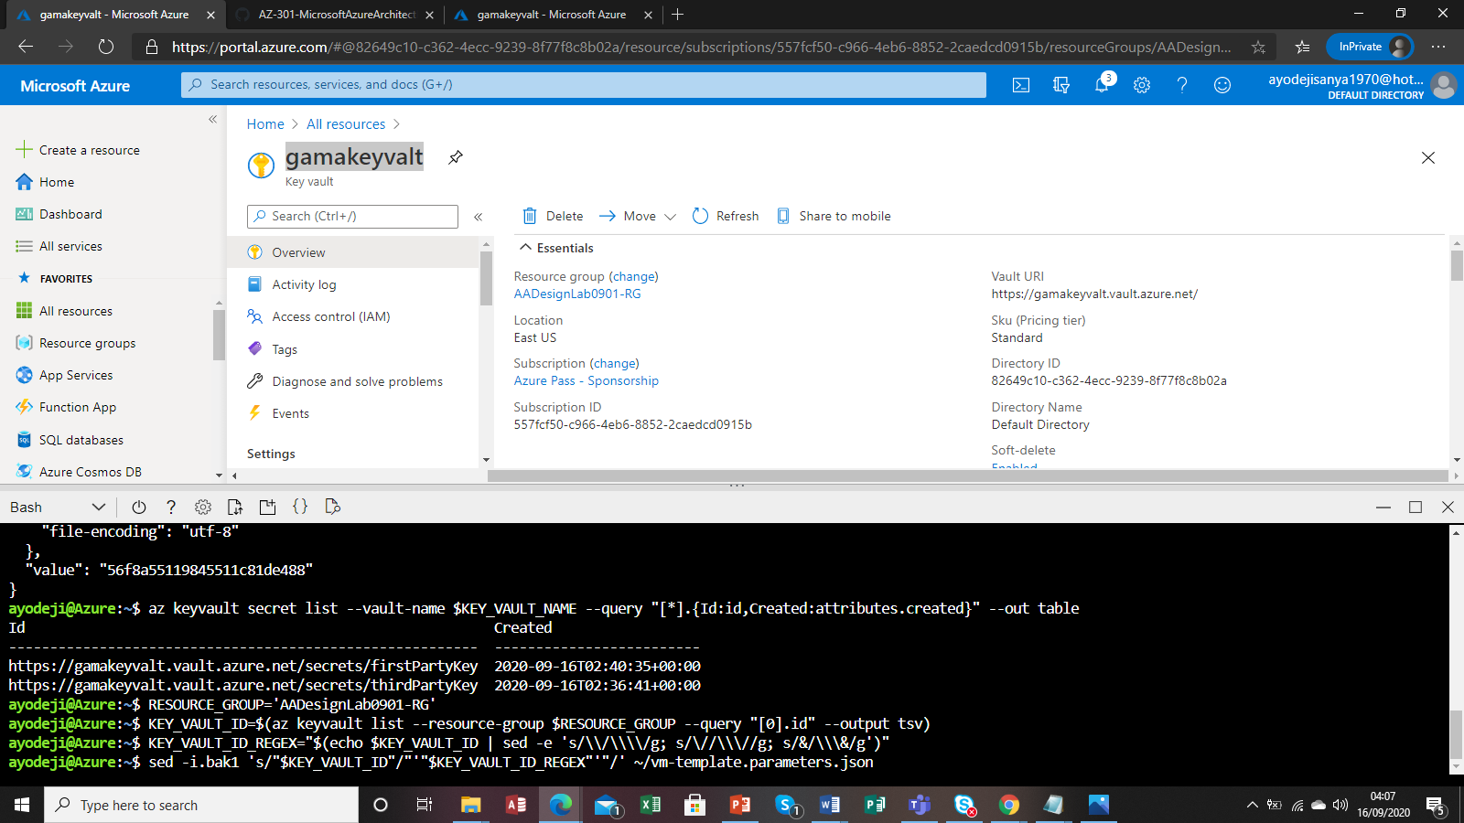

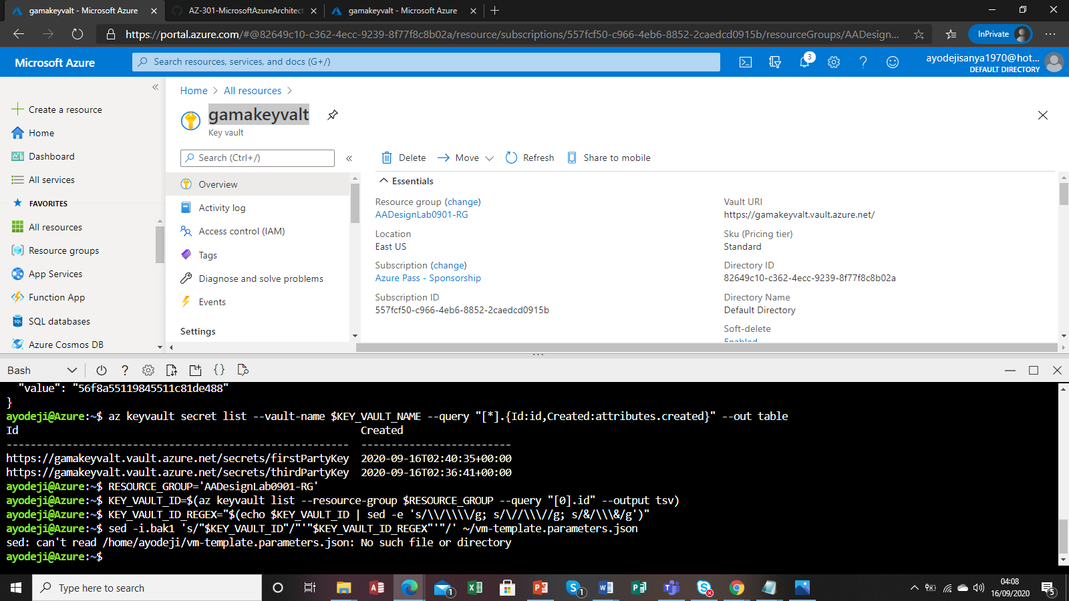

Error

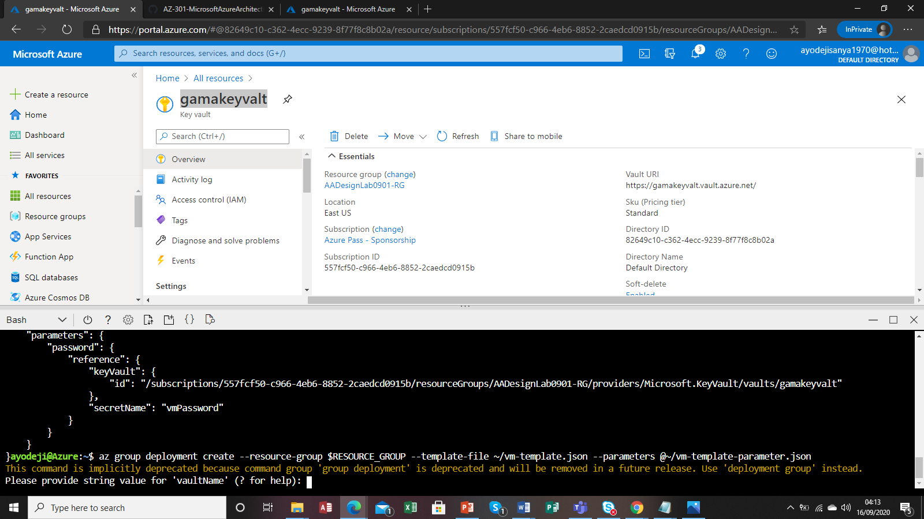

Error resolving host IP address

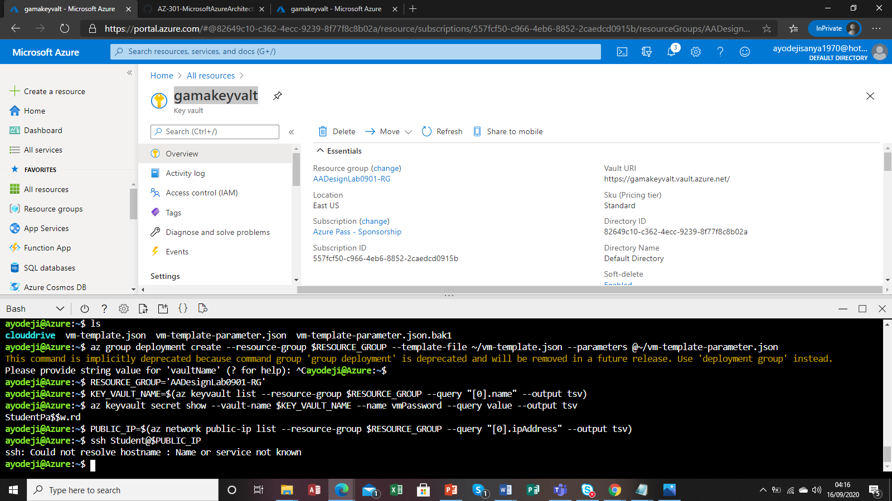

Erro doing the function app on cognitive setup for B2B B2C on MFA using twitter and facebook BOT services it says the service is on read mode when trying to deploy with source code enable but the previous task request CI/CD enabling

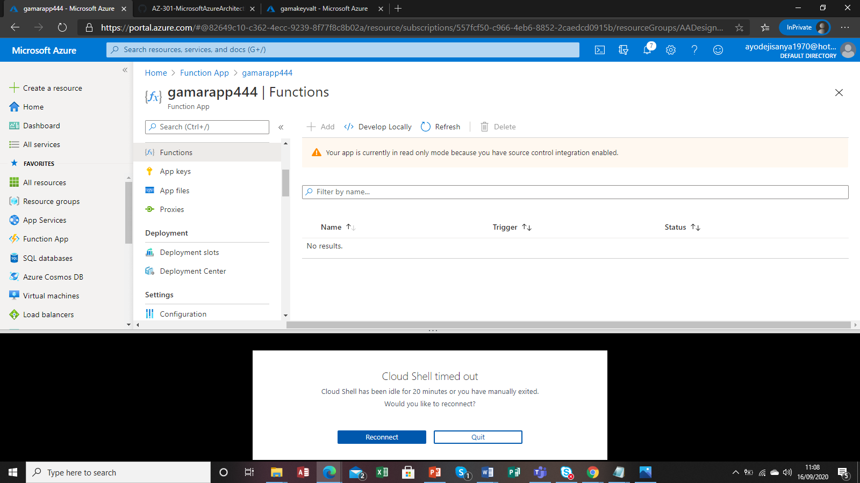

Created logic apps for for B2B B2C on MFA using twitter and facebook BOT services in module 1

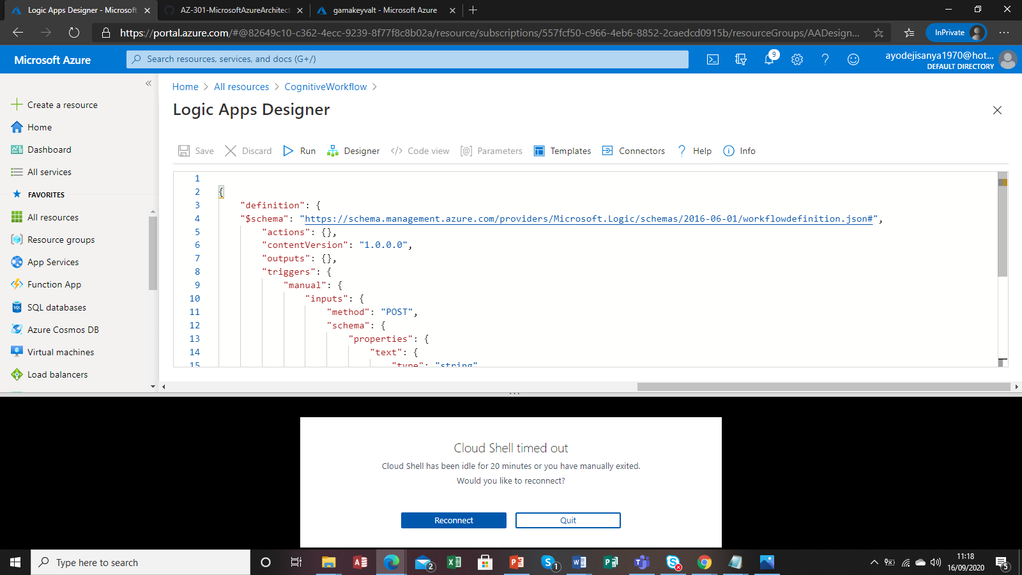

Error on linking functions apps to logic apps **DetermineLanguage** 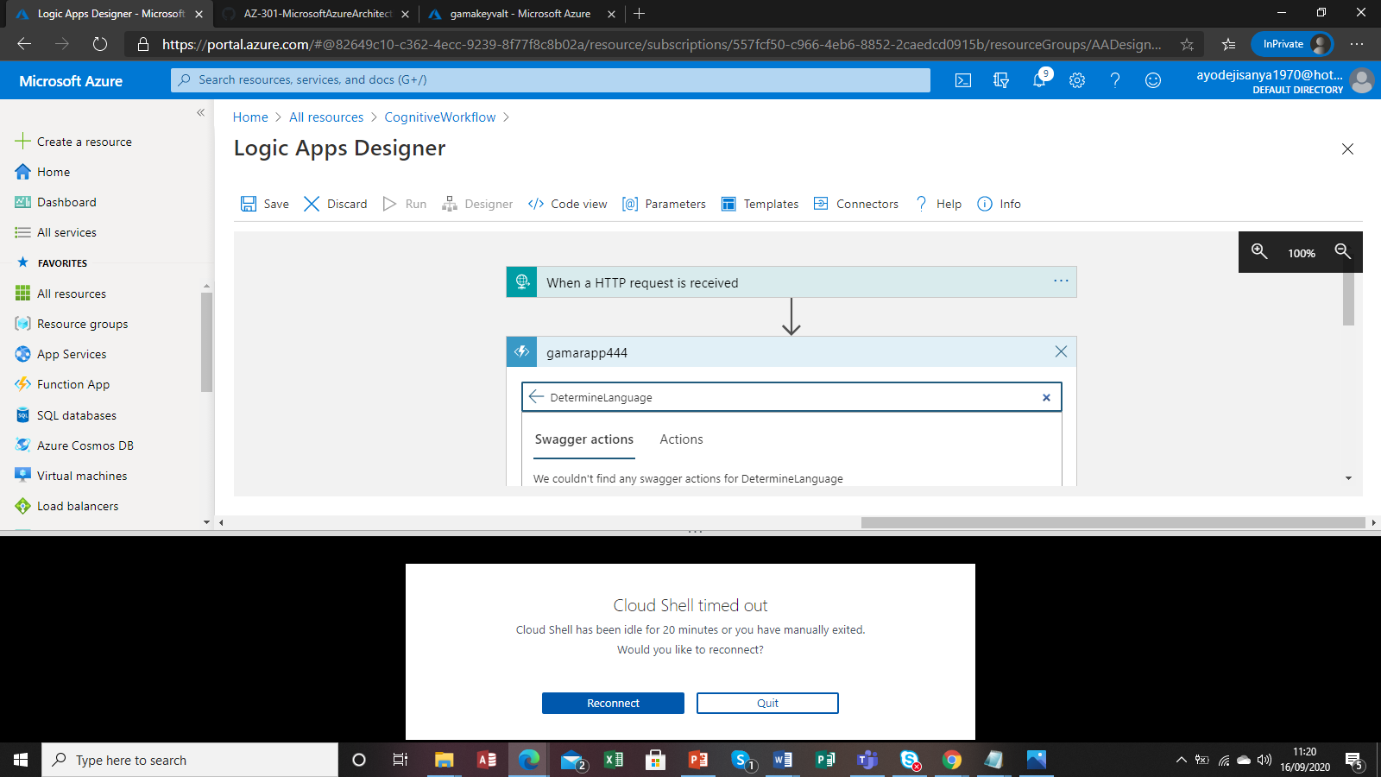

Error logic app post due to **DetermineLanguage**

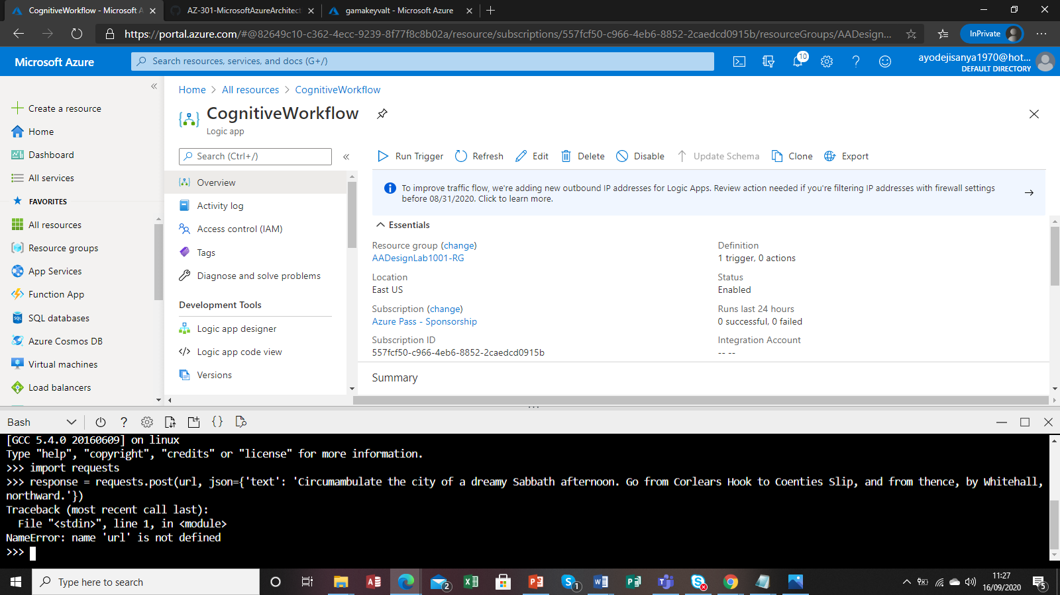



Created congnitive using ARM templates with function and logic apps on CLI

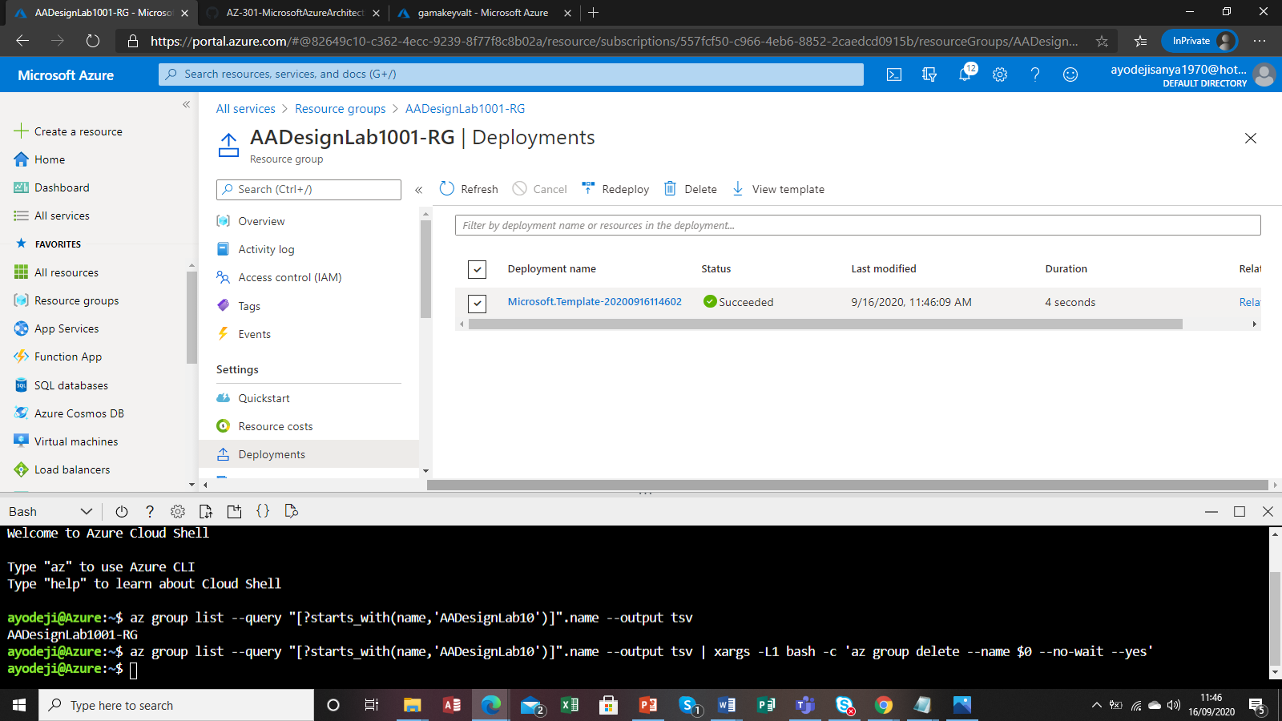

Outputs

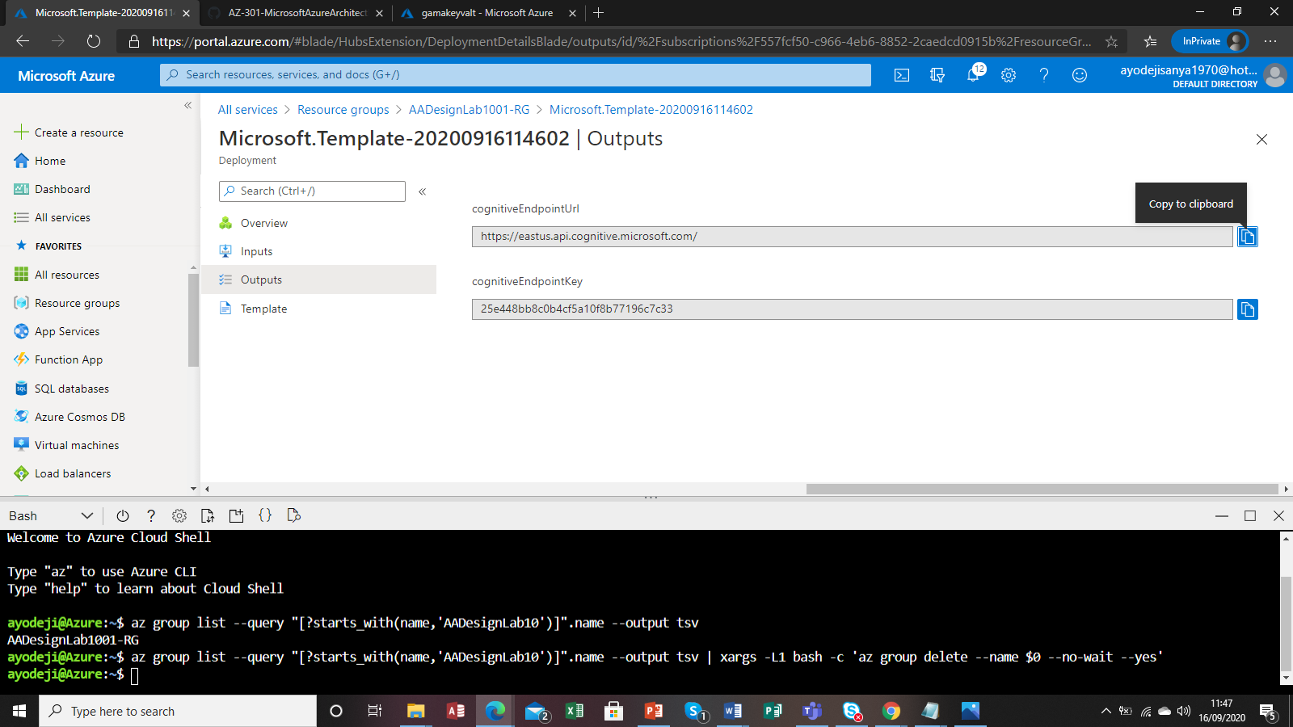

Cannot identify

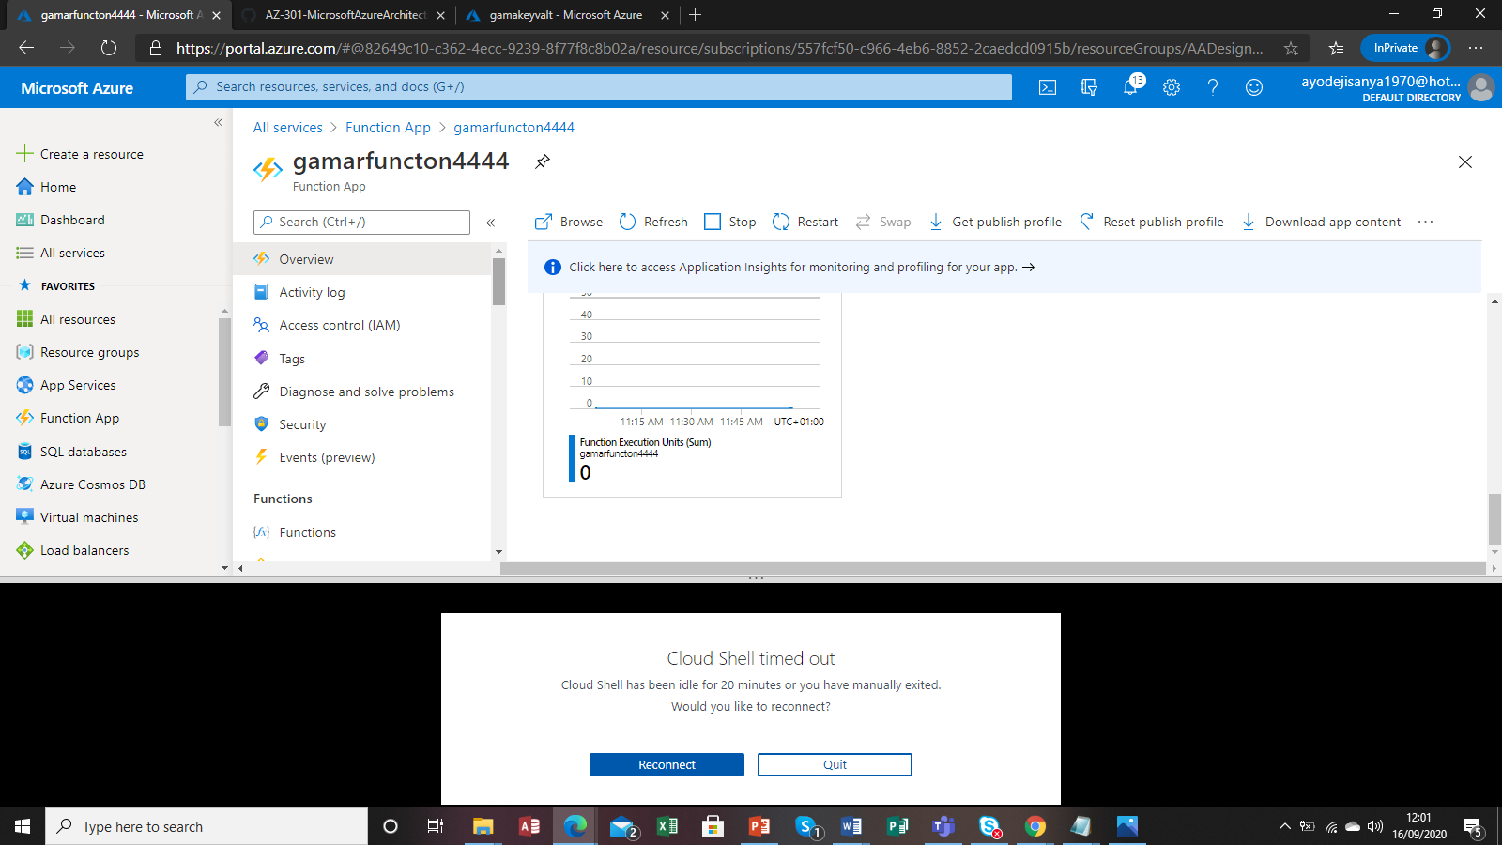

12. On the Application settings tab, locate the Application Settings section. Click the Add new setting link and perform the following tasks:

▪ In the Enter a name text box, type EndpointUrl.

▪ In the Enter a value text box, enter the value of COGNITIVEENDPOINTURL you identified earlier.

13. In the Application Settings section, click the Add new setting link again and pferform the following tasks:

▪ In the Enter a name text box, type EndpointKey.

▪ In the Enter a value text box, type the value of COGNITIVEENDPOINTKEY you identified earlier.

Deployment center

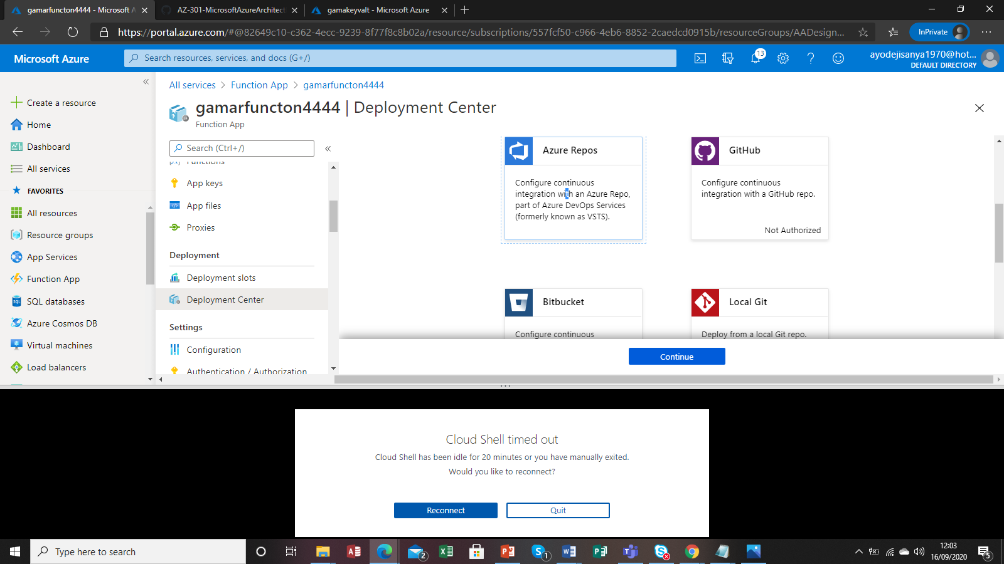

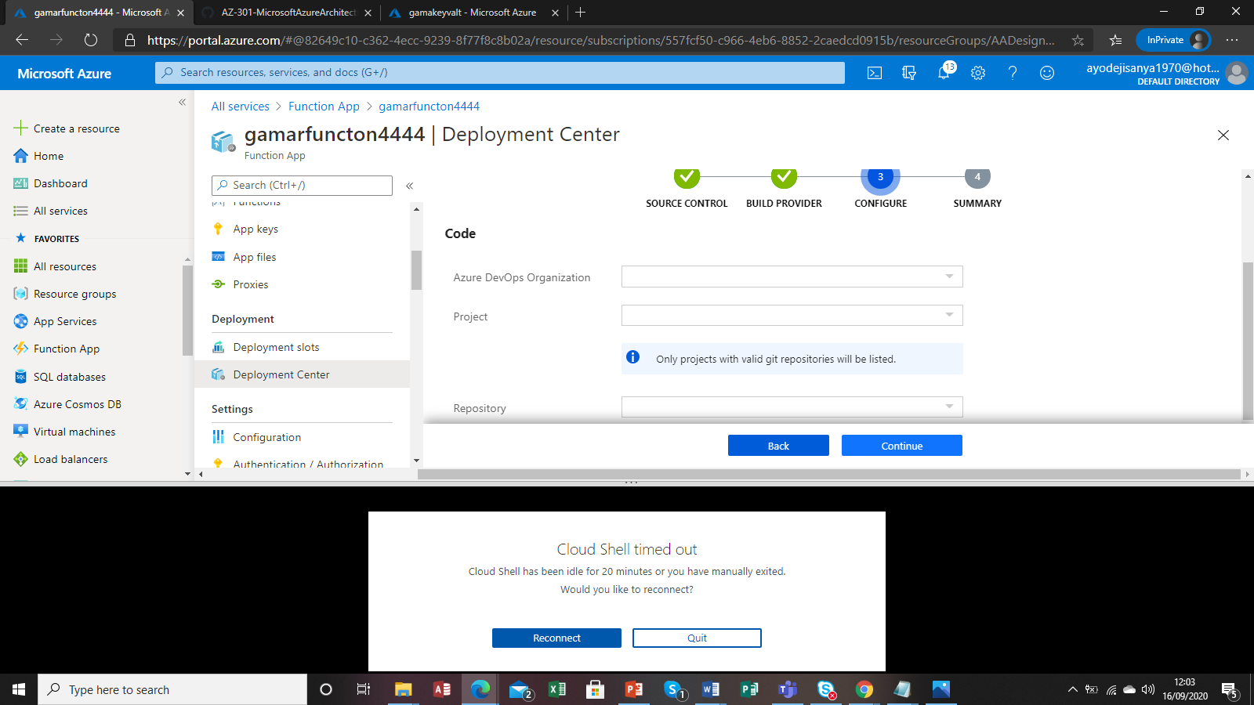

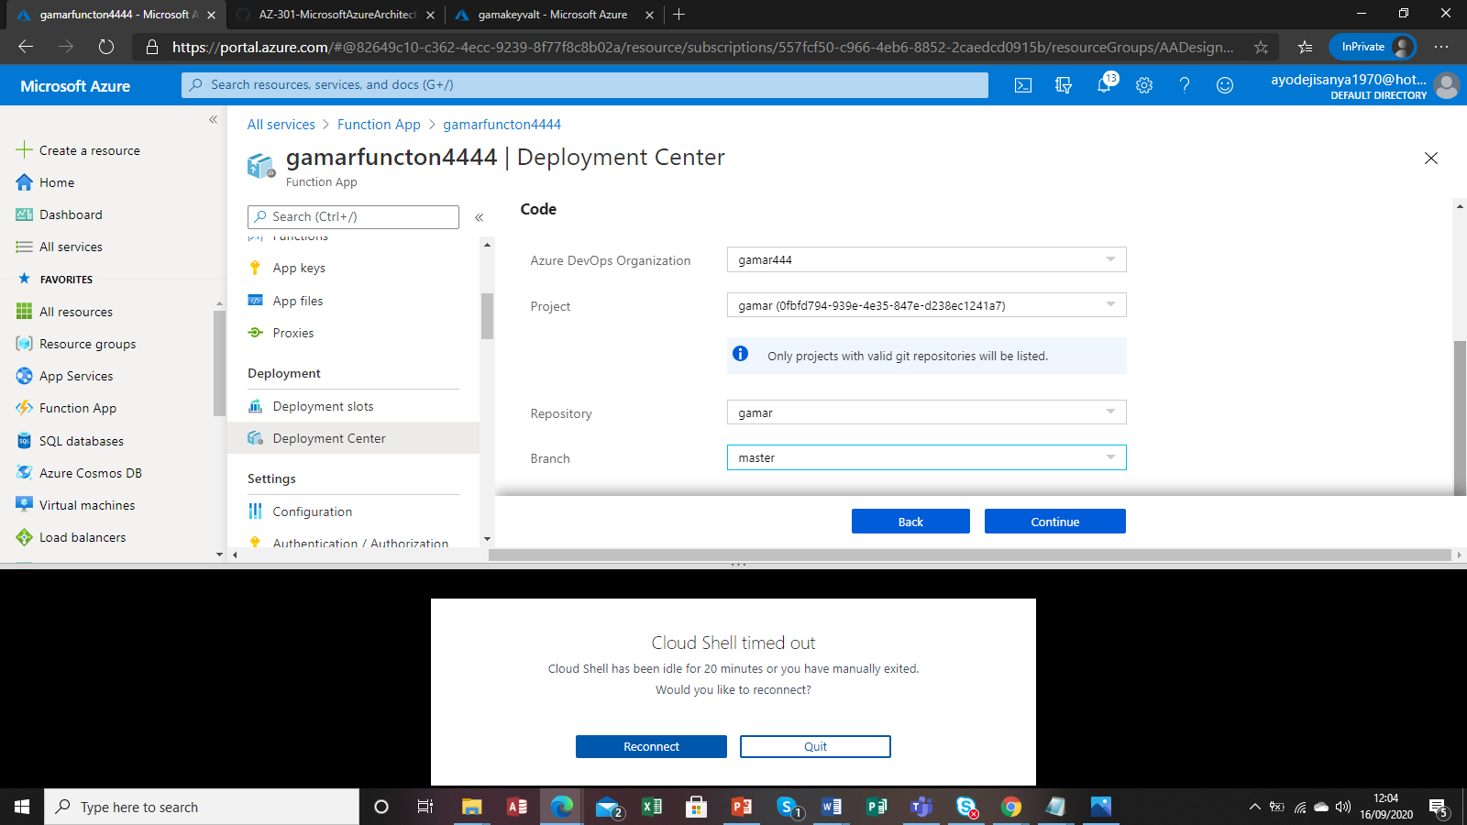

Error on cosmos db creation and using CLI to create variables see

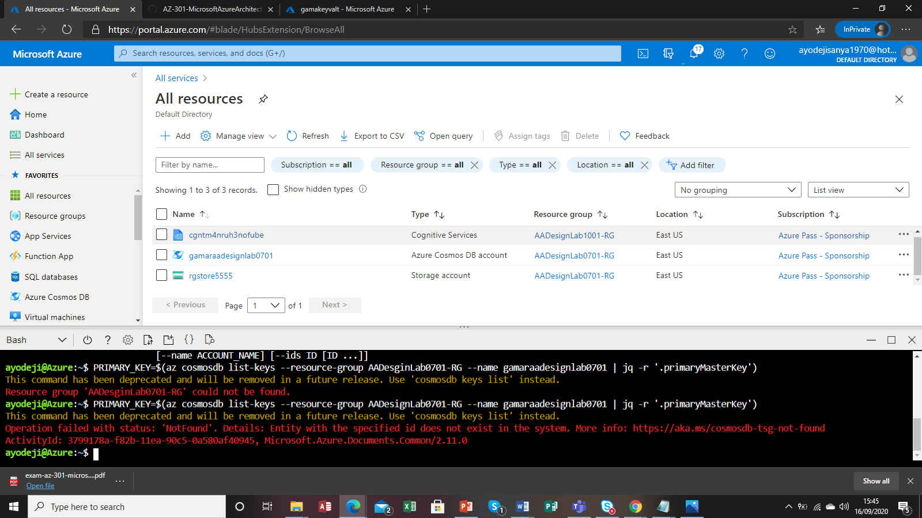

Cosmos db API setup and get and post command

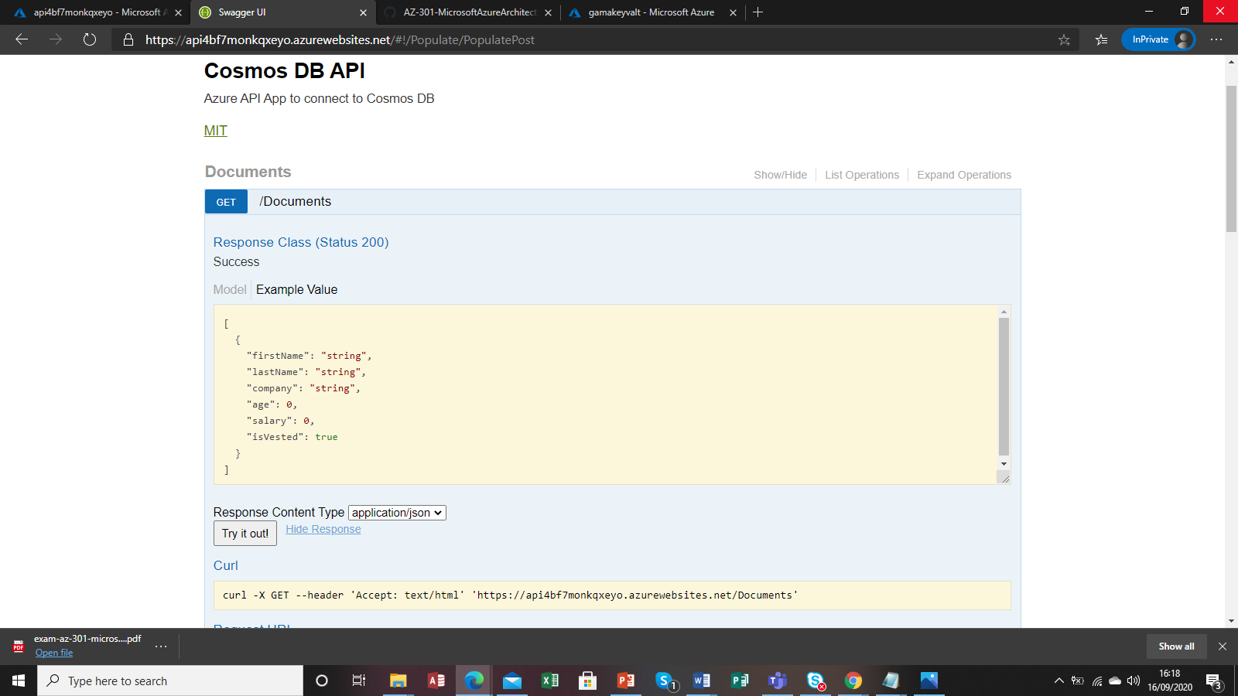

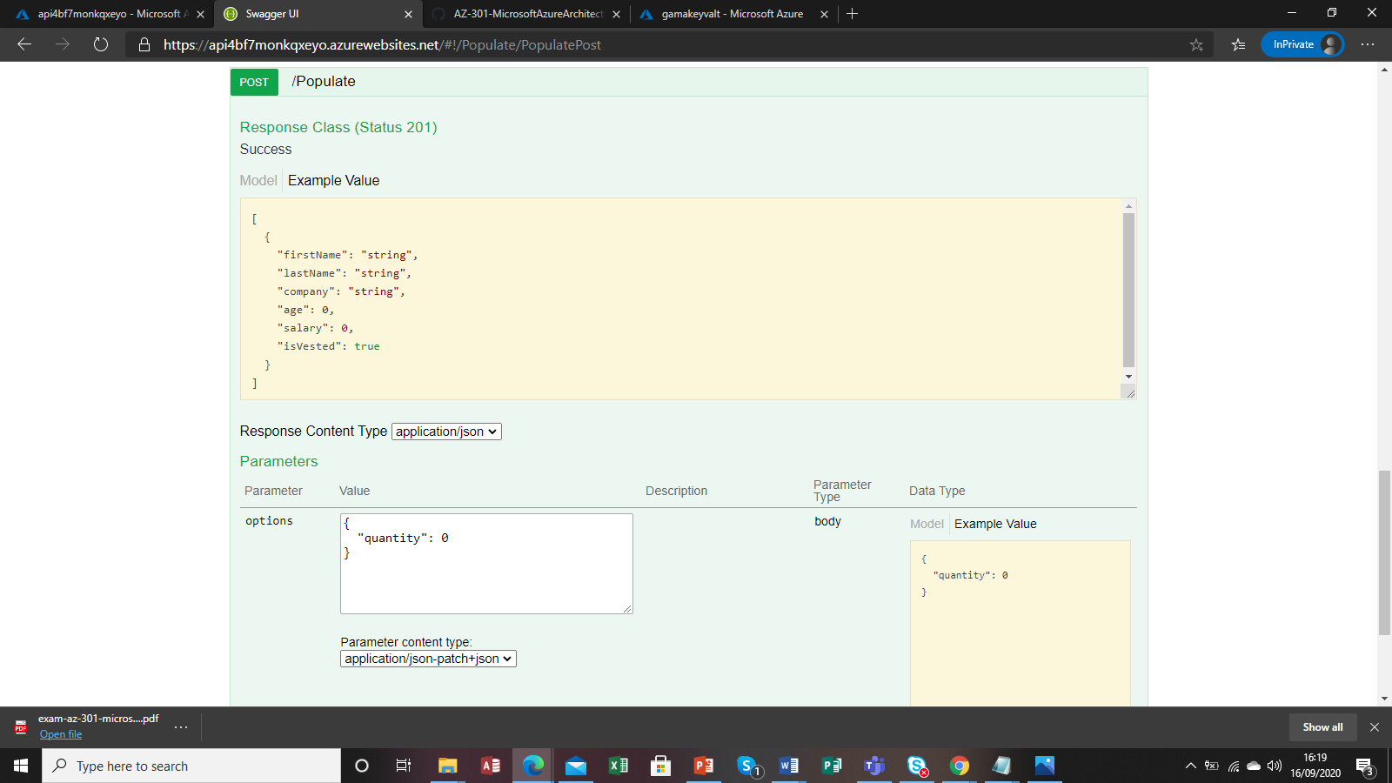

Error

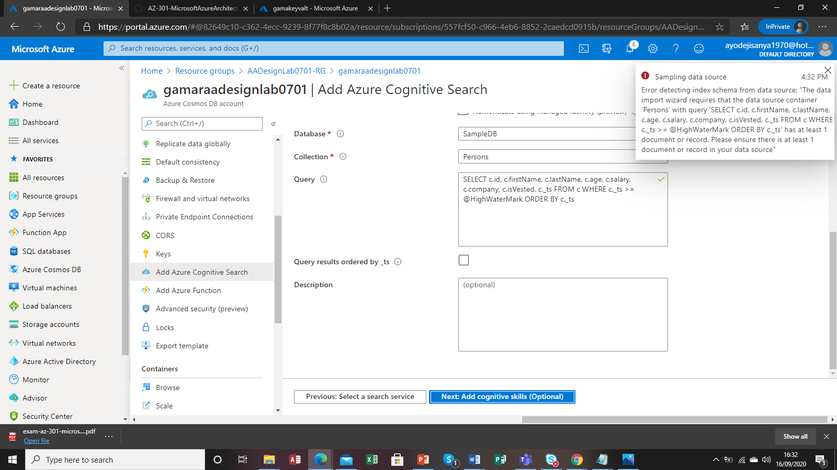

Creating Unix workload VN

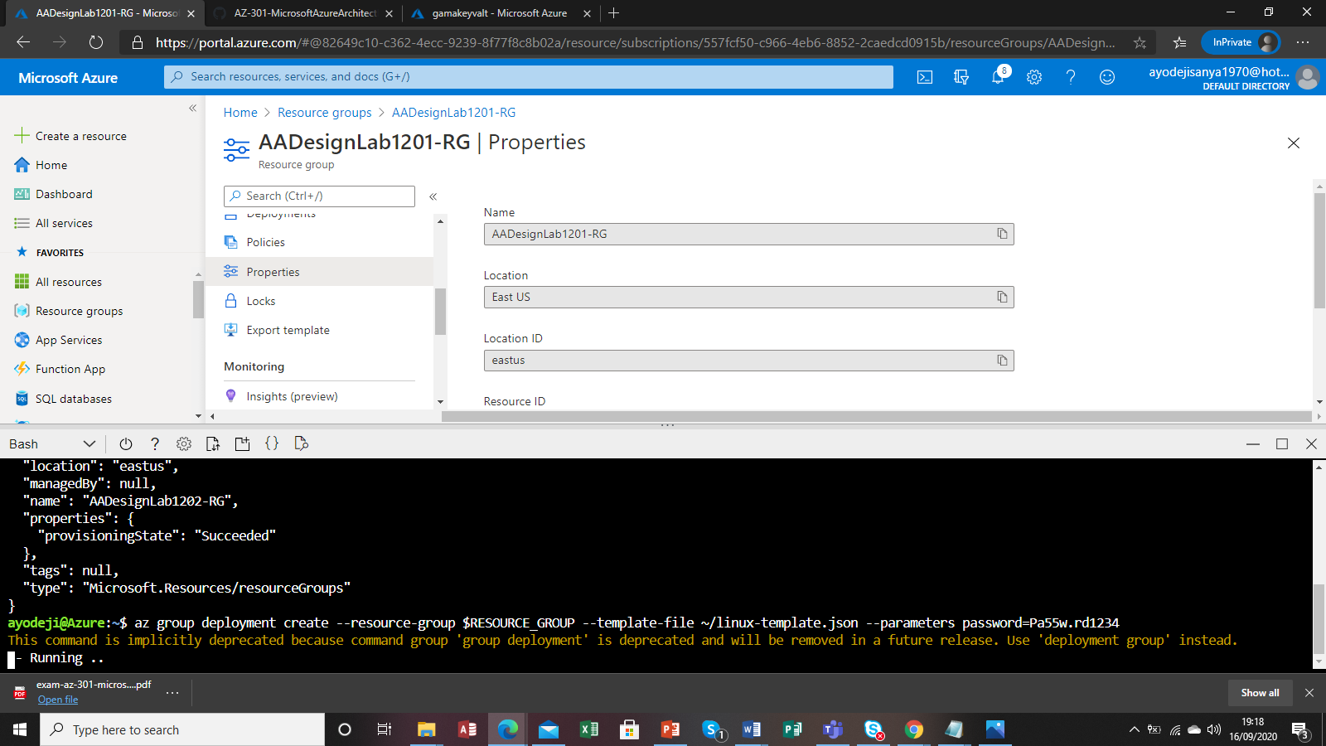

Unix server deployed on DSC with compliance

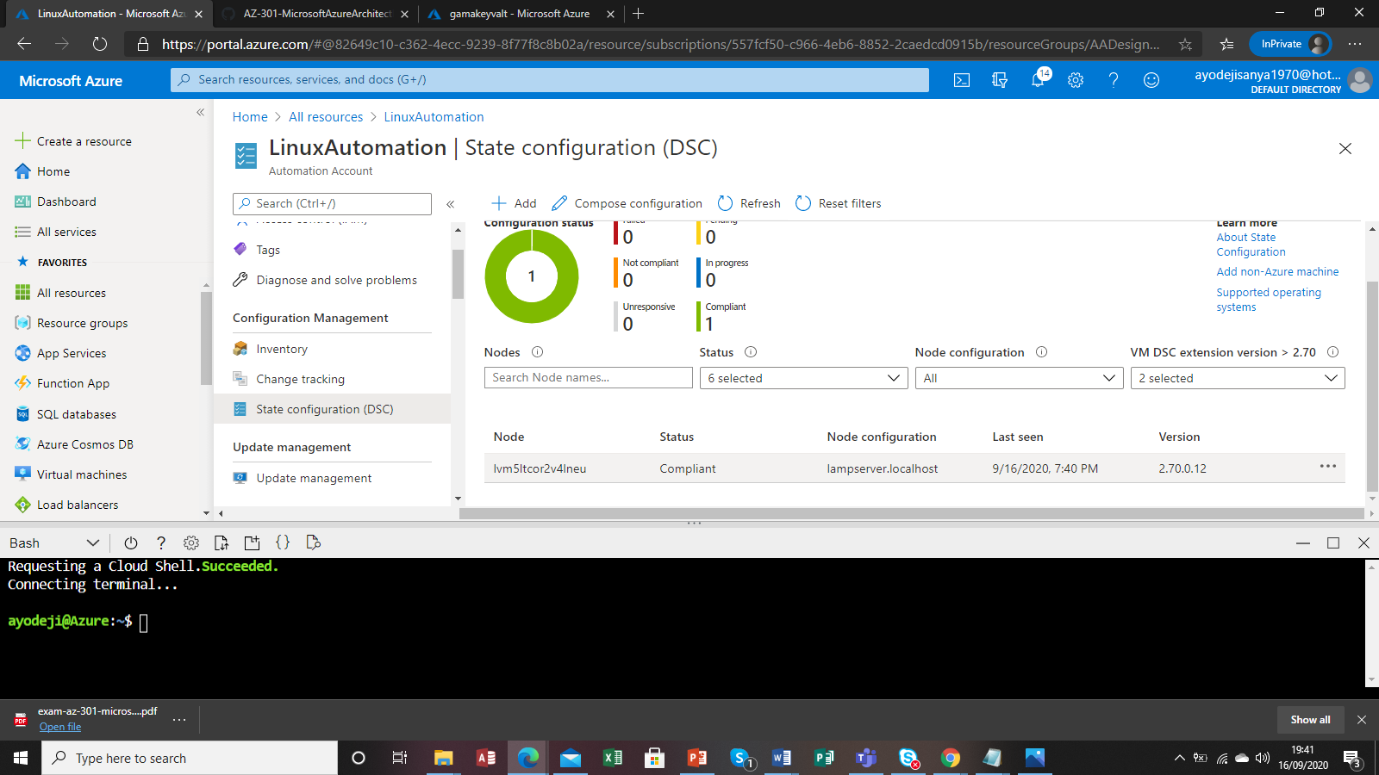

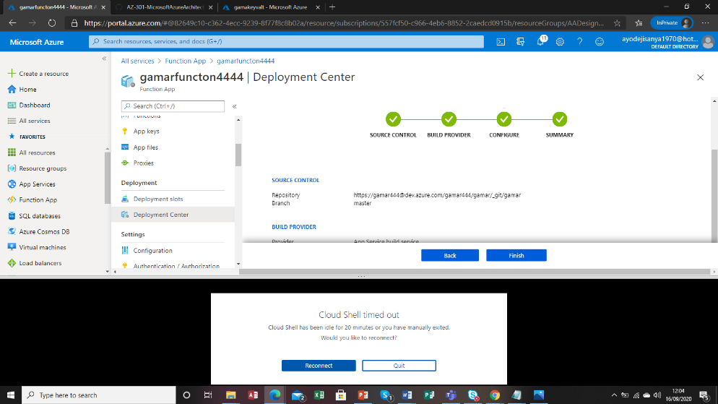

#### Exercise 1: Deploy Function App and Cognitive Service using ARM Template

##### Task 1: Open the Azure portal

1. On the Taskbar, click the **Microsoft Edge** icon.
2. In the open browser window, navigate to the **Azure Portal** ([https://portal.azure.com](https://portal.azure.com/)).
3. When prompted, authenticate with the user account account that has the owner role in the Azure subscription you will be using in this lab.

##### Task 2: Deploy Cognitive Service using an Azure Resource Manager template

1. In the upper left corner of the Azure portal, click **Create a resource**.
2. At the top of the **New** blade, in the **Search the Marketplace** text box, type **Template Deployment** and press **Enter**.
3. On the **Everything** blade, in the search results, click **Template Deployment**.
4. On the **Template deployment** blade, click the **Create** button.
5. On the **Custom deployment** blade, click the **Build your own template in the editor** link.
6. On the **Edit template** blade, click **Load file**.
7. In the **Choose File to Upload** dialog box, navigate to the **\allfiles\AZ-301T01\Module_02\LabFiles\Starter\** folder, select the **cognitive-template.json** file, and click **Open**. This will load the following content into the template editor pane:

{ "$schema": "http://schema.management.azure.com/schemas/2015-01-01/deploymentTemplate.json#", "contentVersion": "1.0.0.0", "variables": { "serviceName": "[concat('cgnt', uniqueString(resourceGroup().id))]" }, "resources": [ { "apiVersion": "2017-04-18", "type": "Microsoft.CognitiveServices/accounts", "name": "[variables('serviceName')]", "kind": "TextAnalytics", "location": "[resourceGroup().location]", "sku": { "name": "S1" }, "properties": {} } ], "outputs": { "cognitiveEndpointUrl": { "type": "string", "value": "[reference(variables('serviceName')).endpoint]" }, "cognitiveEndpointKey": { "type": "string", "value": "[listKeys(variables('serviceName'), '2017-04-18').key1]" } } }

1. Click the **Save** button to persist the template.
2. Back on the **Custom deployment** blade, perform the following tasks:
   * Leave the **Subscription** drop-down list entry set to its default value.
   * In the **Resource group** section, ensure that the **Create new** option is selected and then, in the text box, type **AADesignLab1001-RG**.
   * In the **Location** drop-down list, select the Azure region to which you intend to deploy resources in this lab.
   * In the **Terms and Conditions** section, select the **I agree to the terms and conditions stated above** checkbox.
   * Click the **Purchase** button.
3. Wait for the deployment to complete before you proceed to the next step.
4. In the hub menu of the Azure portal, click **Resource groups**.
5. On the **Resource groups** blade, click **AADesignLab1001-RG**.
6. On the **AADesignLab1001-RG** blade, locate the **Deployments** header at the top of the blade and click the below the **Deployments** label, which indicates the number of successful deployments.
7. On the deployments blade, click the name of the most recent deployment.
8. On the **Microsoft.Template- Overview** blade, click **Outputs**.
9. On the **Microsoft.Template - Outputs** blade, identify the values of **COGNITIVEENDPOINTURL** and **COGNITIVEENDPOINTKEY** outputs. Record these values, since you will need them later in the lab.

##### Task 3: Deploy a function app

1. In the upper left corner of the Azure portal, click **Create a resource**.
2. At the top of the **New** blade, in the **Search the Marketplace** text box, type **Function App** and press **Enter**.
3. On the **Everything** blade, in the search results, click **Function App**.
4. On the **Function App** blade, click the **Create** button.
5. On the next **Function App** blade, perform the following tasks:
   * In the **App name** text box, type a globally unique name.
   * Leave the **Subscription** drop-down list entry set to its default value.
   * In the **Resource group** section, select the **Use existing** option and then, in the drop-down list, select **AADesignLab1001-RG**.
   * In the **OS** section, ensure that the **Windows** button is selected.
   * In the **Hosting Plan** drop-down list, ensure that the **Consumption Plan** entry is selected.
   * In the **Runtime Stack** drop-down list, ensure that **.NET** entry is selected.
   * In the **Location** drop-down list, select the Azure region to which you deployed an instance of Cognitive Service in the previous task.
   * In the **Storage** section, ensure that the **Create new** option is selected and accept the default value of the Storage Account name.
   * In the **Application Insights** section, set the extension to **Disabled**.
   * Click the **Create** button.
6. Wait for the provisioning of the function app to complete before you proceed to the next step.
7. In the hub menu of the Azure portal, click **Resource groups**.
8. On the **Resource groups** blade, click **AADesignLab1001-RG**.
9. On the **AADesignLab1001-RG** blade, in the list of resources, click the newly provisioned function app.
10. On the function app blade, click the **Platform features** tab at the top of the blade.
11. On the **Platform features** tab, click the **Application Settings** link in the **GENERAL SETTINGS** section.
12. On the **Application settings** tab, locate the **Application Settings** section. Click the **Add new setting** link and perform the following tasks:
    * In the **Enter a name** text box, type **EndpointUrl**.
    * In the **Enter a value** text box, enter the value of **COGNITIVEENDPOINTURL** you identified earlier.
13. In the **Application Settings** section, click the **Add new setting** link again and pferform the following tasks:
    * In the **Enter a name** text box, type **EndpointKey**.
    * In the **Enter a value** text box, type the value of **COGNITIVEENDPOINTKEY** you identified earlier.
14. Click the **Save** button at the top of the **Application settings** tab.
15. Back on the function app blade, click the **Platform features** tab at the top of the blade.
16. In the **Platform features** tab, click the **Deployment Center** link in the **Code Deployment** section.
17. On the **Deployment Center** blade that appears, click the **External** button and then click **Continue**.
18. Click **App Service Kudu build server** and click **Continue**.
19. Once the **Code** section is displayed, perform the following tasks
    * In the **Repository URL** text box, type [**https://github.com/azure-labs/cognitive-services-function**](https://github.com/azure-labs/cognitive-services-function).
    * In the **Branch** text box, type **master**.
    * In the **Repository Type** section, ensure that the **Git** option is selected.
    * Click the **Continue** button.
20. Click **Finish** and wait for the deployment to complete before you proceed to the next task.**Note**: You will be able to determine that the first deployment has completed by monitoring the **Deployments** tab. This tab updates automatically.

##### Task 4: Test a function app using Cognitive Services

1. Back on the function app blade, click **Functions** to expand the list of functions.**Note**: You may need to click **Functions** twice to refresh the list of functions.
2. Select the **DetermineLanguage** function from the list of functions.
3. In the **run.csx** pane that opens, click **Test** on the right side of the pane.
4. In the **Test** pane, perform the following tasks:
   * In the **Request body** text box, type the following:

{ "text": "I stuffed a shirt or two into my old carpet-bag, tucked it under my arm, and started for Cape Horn and the Pacific." }

* + Click the **Run** button.
  + Review the output in the **Output** section. The output should identify the language as **en** (English).

**Review**: In this exercise, you created a function app that uses Azure Cognitive Services.

#### Exercise 2: Create a Logic App that uses a Function App

##### Task 1: Create a logic app

1. In the upper left corner of the Azure portal, click **Create a resource**.
2. At the top of the **New** blade, in the **Search the Marketplace** text box, type **Logic App** and press **Enter**.
3. On the **Everything** blade, in the search results, click **Logic App**.
4. On the **Logic App** blade, click the **Create** button.
5. On the **Create logic app** blade, perform the following tasks:
   * In the **Name** text box, enter the value **CognitiveWorkflow**.
   * Leave the **Subscription** drop-down list entry set to its default value.
   * In the **Resource group** section, select the **Use existing** option and then, in the drop-down list, select **AADesignLab1001-RG**.
   * In the **Location** drop-down list, select the same Azure region you chose in the previous exercise of this lab.
   * In the **Log Analytics** section, ensure that the **Off** button is selected.
   * Click the **Create** button.
6. Wait for the provisioning to complete before you proceed to the next task.

##### Task 2: Configure logic app steps

1. In the hub menu in the Azure portal, click **Resource groups**.
2. On the **Resource groups** blade, click **AADesignLab1001-RG**.
3. On the **AADesignLab1001-RG** blade, click the entry representing the logic app you created in the previous task.
4. On the **Logic Apps Designer** blade, scroll down and click the **Blank Logic App** tile in the **Templates** section.
5. On the **Logic Apps Designer** blade, click the **Code view** button at the top of the pane.
6. On the **Logic Apps Designer** blade, review the blank Logic App JSON template:

{ "definition": { "$schema": "https://schema.management.azure.com/providers/Microsoft.Logic/schemas/2016-06-01/workflowdefinition.json#", "actions": {}, "contentVersion": "1.0.0.0", "outputs": {}, "parameters": {}, "triggers": {} } }

1. Replace the default JSON template with the following template that includes an HTTP trigger (**\allfiles\AZ-301T01\Module_01\LabFiles\Starter\logic-app.json**):

{ "definition": { "$schema": "https://schema.management.azure.com/providers/Microsoft.Logic/schemas/2016-06-01/workflowdefinition.json#", "actions": {}, "contentVersion": "1.0.0.0", "outputs": {}, "parameters": {}, "triggers": { "manual": { "inputs": { "method": "POST", "schema": { "properties": { "text": { "type": "string" } }, "type": "object" } }, "kind": "Http", "type": "Request" } } } }

1. On the **Logic Apps Designer** blade, click the **Designer** button.**Note**: At this point, you should see a single step in the designer. This is the "trigger" step that begins a workflow.
2. Click the **+ New Step** button in the designer.
3. In the **Choose an action** section, perform the following tasks:
   * In the search text box, type **Azure Functions**.
   * In the search results, select the action named **Choose an Azure function**.
   * In the next set of search results, select the Azure Function instance you created in the previous exercise of this lab.
   * In the final set of search results, select the **DetermineLanguage** function that will be used for the action.
4. In the **DetermineLanguage** step, perform the following tasks:
   * Click the **Show advanced options** link to display all options.
   * In the **Request Body** text box, type **@triggerBody()**.
   * In the **Method** drop-down list, select the **POST** option.
5. Click the **+ New Step** button in the designer. Click the **Add an action** button to open the dialog for creating an action.
6. In the **Choose an action** dialog that displays, perform the following tasks:
   * In the search text box, type **Azure Functions**.
   * In the search results, select the action named **Choose an Azure function**.
   * In the next set of search results, select the Azure Function instance you created in the previous exercise of this lab.
   * In the final set of search results, select the **DetermineKeyPhrases** function that will be used for the action.
7. In the **DetermineKeyPhrases** step, perform the following tasks:
   * Click the **Show advanced options** link to display all options.
   * In the **Request Body** text box, enter the value **@body('DetermineLanguage')**.
   * In the **Method** drop-down list, select the **POST** option.
8. Click the **+ New Step** button in the designer.
9. In the **Choose an action** dialog that displays, perform the following tasks:
   * In the search text box, type **Response**.
   * In the search results, select the **Action** named **Response Request**.
10. In the **Response** step, perform the following tasks:
    * In the **Status Code** text box, ensure that the value **200** is specified.
    * In the **Body** text box, type **@body('DetermineKeyPhrases')**.
11. At the top of the **Logic Apps Designer** blade, click the **Save** button to persist your workflow.
12. Scroll to the top of the **Logic Apps Designer** area and click the **When a HTTP request is received** step.
13. Copy the value of the **HTTP POST URL** text box. This URL will be used later in this lab.

##### Task 2: Open Cloud Shell

1. At the top of the portal, click the **Cloud Shell** icon to open a new shell instance.**Note**: The **Cloud Shell** icon is a symbol that is constructed of the combination of the *greater than* and *underscore* characters.
2. If this is your first time opening the **Cloud Shell** using your subscription, you will see a wizard to configure **Cloud Shell** for first-time usage. When prompted, in the **Welcome to Azure Cloud Shell** pane, click **Bash (Linux)**.**Note**: If you do not see the configuration options for **Cloud Shell**, this is most likely because you are using an existing subscription with this course's labs. If so, proceed directly to the next task.
3. In the **You have no storage mounted** pane, click **Show advanced settings**, perform the following tasks:
   * Leave the **Subscription** drop-down list entry set to its default value.
   * In the **Cloud Shell region** drop-down list, select the Azure region matching or near the location where you deployedf resources in this lab
   * In the **Resource group** section, select the **Use existing** option and then, in the drop-down list, select **AADesignLab1001-RG**.
   * In the **Storage account** section, ensure that the **Create new** option is selected and then, in the text box below, type a unique name consisting of a combination of between 3 and 24 characters and digits.
   * In the **File share** section, ensure that the **Create new** option is selected and then, in the text box below, type **cloudshell**.
   * Click the **Create storage** button.
4. Wait for the **Cloud Shell** to finish its first-time setup procedures before you proceed to the next task.

##### Task 3: Validate Logic App using Python

1. At the **Cloud Shell** command prompt at the bottom of the portal, type the following command and press **Enter** to open the interactive **python** terminal:

python

1. At the **Cloud Shell** command prompt at the bottom of the portal, type the following command and press **Enter** to import the **requests** library:

import requests

1. At the **Cloud Shell** command prompt at the bottom of the portal, type the following command (replacing the placeholder <logic app POST Url> with the value of your url recorded earlier in this lab) and press **Enter** to create a variable containing the value of your logic app's url :

url = "<logic app POST Url>"

1. At the **Cloud Shell** command prompt at the bottom of the portal, type the following command and press **Enter** to send an HTTP POST request to trigger your logic app workflow:

response = requests.post(url, json={'text': 'Circumambulate the city of a dreamy Sabbath afternoon. Go from Corlears Hook to Coenties Slip, and from thence, by Whitehall, northward.'})

1. At the **Cloud Shell** command prompt at the bottom of the portal, type the following command and press **Enter** to display the output of the Logic App workflow:

print(response.status_code, response.reason, response.text)

1. Close the **Cloud Shell** pane.

**Review**: In this exercise, you created a logic app that leverages the function app created in the previous exercise of this lab.

#### Exercise 3: Remove lab resources

##### Task 1: Open Cloud Shell

1. At the top of the portal, click the **Cloud Shell** icon to open the Cloud Shell pane.
2. At the **Cloud Shell** command prompt, type in the following command and press **Enter** to list all resource groups you created in this lab:

az group list --query "[?starts_with(name,'AADesignLab10')]".name --output tsv

1. Verify that the output contains only the resource groups you created in this lab. These groups will be deleted in the next task.

##### Task 2: Delete resource groups

1. At the **Cloud Shell** command prompt, type in the following command and press **Enter** to delete the resource groups you created in this lab

az group list --query "[?starts_with(name,'AADesignLab10')]".name --output tsv | xargs -L1 bash -c 'az group delete --name $0 --no-wait --yes'

1. Close the **Cloud Shell** prompt at the bottom of the portal.